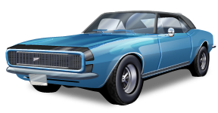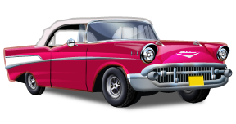 Colonial Heights High School DECA

**Presents**

**3rd Annual**

**Cruise In’ for CANCER**

**Car Show**

**Saturday, June 1st 2013**

**9:00 AM to 2:00 PM**

**Awards Presentation 1:30 PM**

**Colonial Heights High School   
TECHNICAL CENTER Parking Lot**

**3451 Conduit Road**

**Colonial Heights, VA 23834**

**Top 25 Awards, Best of Show (any year),  
 People’s Choice, Principal’s Award,   
Best on Two Wheels, Specialty Award, Best Unfinished**

**Dash plaques to the first 30 registered entries**

**Cash drawing for pre-registered entries**

**OPEN, JUDGED SHOW**

**$10.00 Pre-registered entries (must be postmarked by May 24th)**

**$15.00 Same-day registration and any entries postmarked after May 24th  
Street Rods, Muscle Cars, Antiques, Customs, Trucks, Motorcycles,   
Emergency Vehicles, and Specialty Vehicles are welcome!**

**All vehicles must be set up prior to 11 AM to be judged (no exceptions)**

**This is a RAIN OR SHINE EVENT**

**If the event is cancelled due to inclement weather, no refunds will be issued as we are donating proceeds from this event to   
The Paredes Foundation for Breast Cancer Research**

**Concessions/Food and Portable Restrooms will be available on site**

**DJ (Wolf Man John) 50/50 Raffle, T-Shirts**

**FREE ADMISSION FOR SPECTATORS**

**Vendor/Club spaces available**

**Standard space size 10’ X 10’ $25.00 before May 24th**

**NO ELECTRICITY will be available**

**If needed, vendors/clubs must provide their own source of electricity**

**Registration Form/Information/Questions/-Lesly McBride 524-3405 X131**

**Lesly_McBride@colonialhts.net**